**Balochistan:**

Chotok Waterfalls

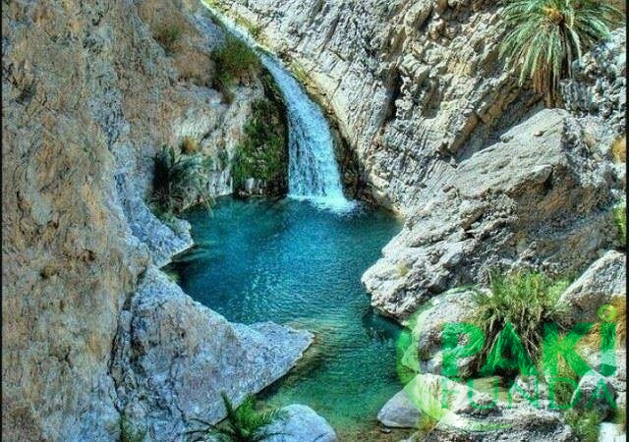

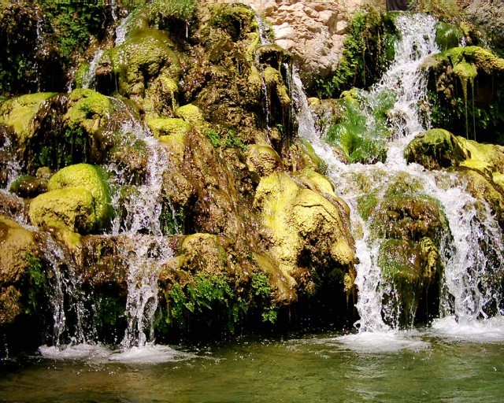

**Chotok Waterfalls** also known as **Moola Chotok Waterfalls** are situated in a village Moola, Khuzdar District of Balochistan the province of Pakistan. Moola is a village and Tehsil of Khuzdar District which is 80 kilometres (50mi) away from Khuzdar. Chotok waterfalls falls between the two hills into a stream of cool water. Khuzdar appears as **Khnenta** in the Zend Avesta and is one of the sixteen beautiful lands created by Ahura Mazda. Khuzdar was the capital of the Brahui kingdom of Makran.